Software aging prediction based on ARMA model
A method of ARMA (Auto Regression Moving Average) model is adopted to study the software aging phenomenon in Apache server. The proposed Time-series ARMA model is built through relative data to predict the performance aging of software and estimate resource exhaustion time. The results are then compared with previous Sen Slope Estimation method and found to be more efficient. Firstly, set up parameters of the Apache and the number of requests from clients, and determine the capacity of Apache server. Secondly, parameters of Slope Estimation method are determined, and an ARMA model is built. Finally, after training the ARMA and Slope Estimation method respectively, the training and prediction results of these two models are derived.
Key words: software aging, ARMA models, Sen slope estimation, Apache server

- Introduction
随着计算机硬件和软件系统的飞速发展，计算机的软件性能不断提高，计算机软件的复杂性也大大提高。The computer software performance and complexity is advancing all the time with the quick development of the computer hardware and software system. 软件在长期不断的运行过程中，产生的系统内存泄露，未释放的文件锁，舍入误差的积累，大量的存储空间碎片等原因会导致软件性能的衰退，这种现象称为软件老化[]。Software
aging^{[1,2]} is a phenomenon observed in a software application executing continuously for a long period of time, where the state of software degrades and leads to performance degradation. The main causes of aging are memory leaks, unreleased file-locks, numerical round-off errors accumulation and large numbers of storage space chips. 为了对抗这种软件性能衰退，Y.Huang[]提出了一种积极的“软件恢复”技术。软件恢复包括停止应用程序的运行，释放操作系统的资源，刷心操作系统资源列表，重新初始化应用程序中的数据结构等。To confront with software aging, Y.Huang^{[1]} et al. proposed a proactive technique called “software rejuvenation”. Software rejuvenation involves stopping the running software, cleaning its internal state and then restarting it. “软件恢复”技术的主要问题是恢复操作的时间如何安排，怎样进行老化趋势的预测，还有如何精确确定重启时间等。The key problem of “Software rejuvenation” is when to schedule it and how to detect the aging trend, and thus determine accurately the time to restart it.
In the face of an increasing error rate and the costs of rejuvenating a software system, an optimal timing of software rejuvenation should be sought. Approaches used for analysing and solving this optimization problem can be grouped into model-based ones, and measurement-based ones[].
The model-based approaches are designed to establishing analytic models of system regression, and analysing these models for determining the effectiveness of software rejuvenation. Garg S^{[3]} et al. proposed a Markov regenerative Petri net model to deal with periodic rejuvenation and determinate intervals between successive rejuvenations. Dohi et al.[] formurated software rejuvenation models as semi-Markov reward processes.
Measurement-based studies of software aging and rejuvenation on general computer systems has been carried out in previous work. In this paper, we adopt a measurement-based approach using time-series analysis to detect software aging and estimate resource exhaustion times due to aging in a web server.
In this paper, system performance parameters such as load average, response time, and buffercache used are collected, an ARMA model is established to evaluate and forecast some performance parameters.
The rest of the paper is organized as follows: In Section 2, we discribe the experimental setup and the data sets collected. The analysis techniques based on time-series for detection and prediction of software aging is discussed in Section 3. Section 4 contains concluding remarks.
- Experimental setup

2.1. Experimental settings

Four computers are composed of a network through a switch connecting, and one of them can be a server (P3, 933MHz, Memory 256M) with Fedora8 operating system. Apache is the most widely used Web server software. We install the Apache 1.3.41 software to simulate the Web server on the server that it can offer Web service. Others are clients (P4, double core 3GHz) which install sending load software to simulate plentiful PC accesses. A monitor called “systeminfo” is installed on the server, which collects system information reading the system information file of the Linux virtual file systems file /proc. A test program wrote in Perl is installed on clients. It can send large number of loads through the program “test” invoking “httperf” software periodically, and get the average server response time which “httperf” returning. The system performance parameters of load average, response time, and buffercache used are collected, which is used to study the software aging. The framework of the experimental platform is as shown in Fig1.
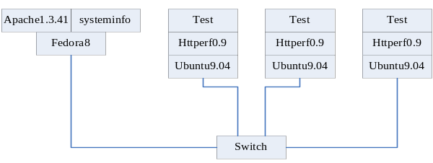
Fig.1 Experiment platform framework
Apache software provides a counteraction aging strategy in itself. Firstly, if MaxPerquestsPerChild is set as a nonzero value N, well then a subprocess will be killed by its parent process after it processing N requests, and creates a new subprocess to process requests. If it is set as 0, then the subprocess will not be killed forever when the process is running. The parameter MaxClients limits the max number of subprocesses which parent process can creates, namely the number of requests that Apache can process simultaneously. Each subprocess uses up about 0.4MB memory space. If the value is out of the size, the memory must be exhausted quickly which lead to the system breakdown. If the value is too small, then only a small number of clients can connect simultaneously. Secondly, the parameter MaxSpareServers sets the maximal number of idle subprocesses. If the number of idle subprocesses is greater than the value, the Apache will kill some idle subprocesses automatically to reduce the used memory place. This can be viewed as a measure of the Apache software counteracting aging. If the value is set less than the value of MinSpareServers, the Apache will adjust it to MinSpareServers+1 automatically. To speed up the software aging^{[5, 11]}, we abolish the Apache counteracting aging strategy. So we set the Apache parameters as follows:
MaxClients=MinSpareServers=StartServer=250;
MaxSpareServers=0.

2.2. Determination of the capacity of server
Before the experiment, we need to set the speed of clients sending requests. Firstly, we need to determine the capability of the server, and we can use the method Lei Li^{[5]} proposed. Httperf^{[12]} is a tool for measuring web server performance. It provides a flexible facility for generating various HTTP workloads and for measuring server performance. In the experiment, we increase the send speed of httperf constantly through invoking httperf periodically, and gather all kinds of information which httperf returns. Analyzing all kinds of information which the httperf returns, such as connection rate，error rate and so on, we can estimate the capability of the server. As shown in Fig2, (a) is error rate; (b) is connection rate.
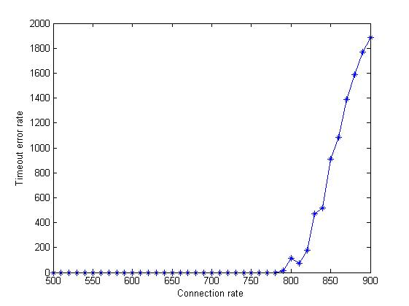

Fig.2 Testing the capacity of the server (a)
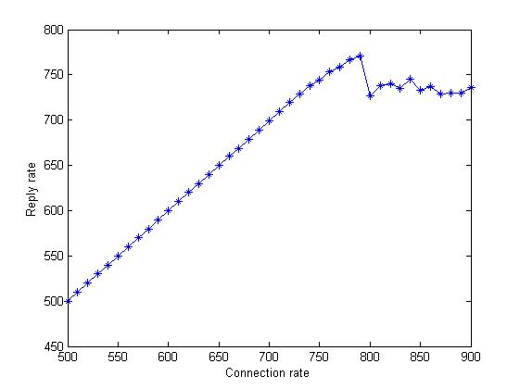

Fig.2 Testing the capacity of the server (b)
As can be seen from the Fig2, when the send rate of the clients come up to about 770q/s, the response rate of the server declines sharply and the error rate rises steeply. Therefore, it can be decided that the capacity of the server is 770q/s. It requires the Apache working in full load that the Apache software aging can be accelerated. The three clients send load averagely to the server, so we can set the requests of every client to 255 requests per second equally.
- ARMA model
The process of ARMA forecasting as follows:
Step1: Determine whether the series is stationary or not. If the time series is not stationary, it can often be converted to a stationary series by differencing. That is, the original series is replaced by a series of differences. An ARMA model is then specified for the differenced series.
Step2: Plot the ACF and PACF of the measured data to determine an appropriate initial model.
Step3: Choose an appropriate method to estimate parameters for the initial model selected.
Step4: Check about the selected model. The analyst should consider a new or modified model and continue the analysis until a satisfactory model has been determined.
Step5: Forecast applying. Produce forecasts for some time using the model selected in Step 4.
3.1 Stationary determination
In our case, a critical step is determining whether the time series is stationary or not. David Dickey and Wayne Fuller ^{[1]} proposed the unit root test (DF test) method to determine the time series stationary. If a time series do not have a unit root, the time series is stationary.
Consider the following model:
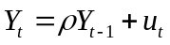 (1)
where 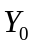=0, is a real number, and {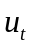} is a sequence of independent normal random variables with mean zero and variance . We can get following formulas from (5.1):
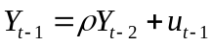 (2)
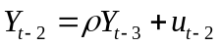 (3)
…
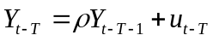 (4)
We substitute (4)… (3)、(2) to neighborhood formulas in turn, and get the following form:
(5.5)
The time series converges (as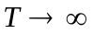) to a stationary time series if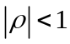. If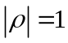, the time series is not stationary and the variance of is 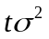. The time series with 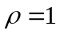 is sometimes called a random walk. If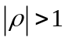, the time series is not stationary and the variance of the time series grows exponentially as t increases.
For the (1), the DF test equivalently is the significance test to its coefficients. The null hypothesis established is: 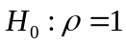. If null hypothesis is rejected, has not a unit root. Hence, is stationary; if null hypothesis is accepted, it means that has unit roots. Therefore, is non-stationary.
We use DF test to determine that our data is stationary. The result shown as following: , null hypothesis is rejected. The result indicates that the measured data is stationary.

3.2 modeling identification
An autoregressive moving average model is the most usual technology for mathematical modeling. In this section, we introduce ARMA models that are used for modeling and estimating software aging. An autoregressive moving average model, ARMA (p, q), has the following form:
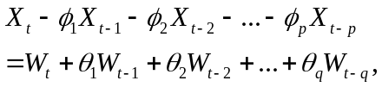 (1)
where 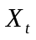 is a stationary random process, 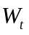 is a white noise series with mean zero and variance 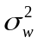, is autoregressive order of the model, is the moving average order of the model, ’s and ’s are constants. If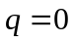, the model reduces to moving average model of order p, abbreviated as AR (q). And if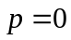, the model reduces to moving average model of order q, abbreviated as MA (q).
A critical step in using ARMA models to analyzing and forecasting time series data is determining the order of the model. Autocorrelation Function (ACF) and Partial Autocorrelation Function (PACF) provide important information in doing this. ACF is defined as
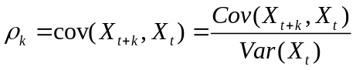. (2)
Another function called the partial autocorrelation function (PACF) is defined for mean-zero stationary time series. Formally, for a stationary time series,, the PACF, 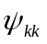,k=1,2,…, is defined as
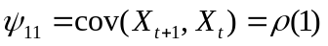 and
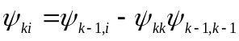, (4)
where 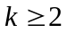, 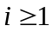.
While the ACF of a MA (q) process becomes zero after q lags, the ACF of AR and ARMA processes become smaller with larger lags, but they do not cut off. So the cutting off of 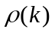 after q lags can be regarded as a signature of the MA (q) model. While the PACF of an AR (p) process becomes zero after p lags, the PACF of MA and ARMA processes become smaller with larger lags, but they do not cut off. So the cutting off of 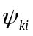 after p lags can be regarded as a signature of an AR (p) model. By considering the graph of ACF can also determine whether the series is stationary or not. If a graph of ACF of the time series values either cuts off fairly quickly or trails off fairly quickly, then the time series values should be considered stationary. If a graph of ACF trails off extremely slowly, then the time series values should be considered non-stationary. Table 1 gives the behavior of the ACF and PACF for AR, MA and ARMA models.
Table1. ACF and PACF for ARMA Models
 | AR(p) | MA(q) | ARMA(p, q)
ACF | Trails off | Cuts off at lag q | Trails off
PACF | Cuts off at lag p | Trails off | Trails off

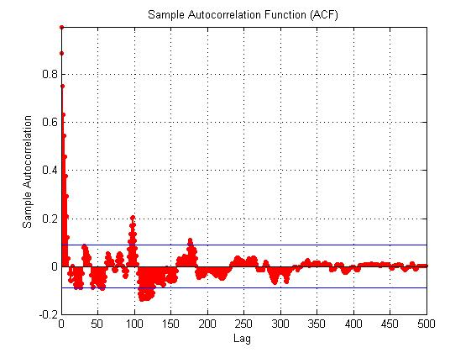
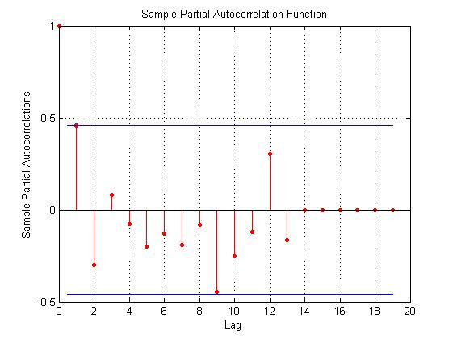
Figure1. ACF and PACF of data
We compute the ACF and the PACF for the output. The ACF and the PACF help us decide the appropriate model for the data (Table 1). For example, from the ACF and PACF of data in figure 1, we observed that the ACF and the PACF become smaller with larger lags, but they do not cut off. Therefore, we can determine that an ARMA (p, q) model is suitable for this data series.
In time series analysis, the Akaike Information Criterion (AIC) is used to measure the goodness of fit of a model [2]. Based on different p value and q value, we establish models respectively. Then estimate parameters and compare the AIC value in every model. The model has the minimum AIC value is the optimal model. In our case, we used the first 500 hours data (1-500) to estimate the parameters. The (p, q) value computed is (28, 21). Figure 2 shows the one-step-ahead predicted data which is computed using the established model and the data measured up to one hour before the predicted time point. From the plot, we can see that the predicted values are very close to the measured values.

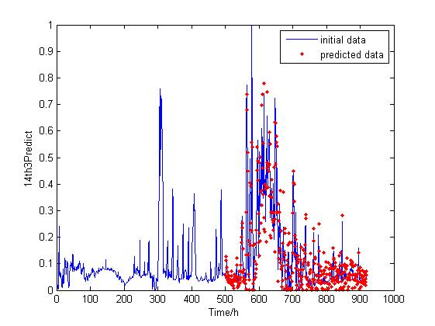
Figure2 Measured and one step ahead predicted data

